Business Model Canvass

Key Partnerships  Who are our key partners?  Who are our key suppliers?  Which key resources are we acquiring from partners?  Which key activities do partners perform?  Motivations  Optimisation and Economy of Scale  Reduction of Risk and Uncertainty  Acquisition of resources and activities | Key Activities  What key activities do our value propositions require?  Our distribution channels?  Customer relationships?  Revenue streams?  Categories of Key Activities  Production  Problem Solving  Platform/Network  Logistics | Value Propositions  What do we deliver to the customer?  Which one of our customer's problems are we helping to solve?  What bundles of products and services are we offering to each customer segment?  Which customer needs are we satisfying?  Characteristics |  |  | 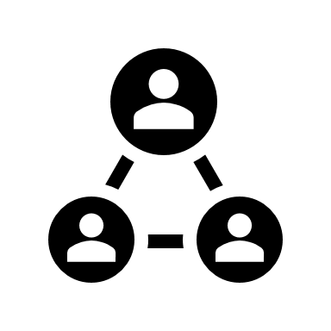  Customer Relationships  What type of relationship does each customer segment expect?  What is in place now?  How are they integrated in our business model?  How costly are they?  Examples  Dedicated Personal Assistance  Self-Service  Automated Services  Communities |  | Customer Segments  For whom are we creating value?  Who are our most important customers?  Types of Customer Segments  Mass Market  Niche Market  Segmented  Diversified
 |  | Performance  Convenience Accessibility Newness  Usability  Design | Cost Reduction  Risk Reduction  Customisation  Brand  Status  Price
 | Key Resources  What key resources does our value proposition require?  Our distribution channels?  Customer relationships?  Revenue streams?  Types of Resources  Physical  Intellectual (Brand Patents, Copyrights, Data)  Human  Financial |  |  |  | Channels  How can our customer segments be reached?  How can the channels be integrated?  Which channels we use today?  Which one works best?  Channel Types  Sales Force  Web Sales  Own/Partner Store  Wholesale
Cost Structure  What are the most important costs inherent in our business model?  Which key resources are most expensive?  Which key activities are most expensive?  Is your business:  Cost Driven (Leanest Cost Structure, Low Price Value Proposition, Maximum Automation, Extensive Outsourcing)  Value Driven (Focused on value creation, Premium Value Proposition)  Examples of Characteristics  Fixed Costs  Variable Costs  Economies of Scale  Economies of Scope |  |  |  | Revenue Streams  For what value are our customers really willing to pay?  For what do they currently pay?  How are they currently paying?  How would they prefer to pay?  How much does each revenue stream contribute to overall revenues?
 |  |  |  | Types  Asset Sale  Usage Fee  Subscription Fee  Advertising  Lending/Renting/Leasing  Licensing  Brokerage Fee |  | Fixed Pricing  List Price  Product Feature Dependant  Customer Segment Dependant  Volume Dependant |  | Dynamic Pricing  Negotiation (bargaining)  Yield Management  Real-time Market  Auctions

